Approved by: Trust Board | Ratified date: 13 October 2025
Last review date: 02 October 2024 | Next review date: 01 October 2026



Version:

1.2

INTRODUCTION
This Fire Safety Policy and Management Plan reflects the importance the School and its Governing Body attaches to the safety of its staff, pupils, members of the public and other persons affected by its activities or its premises in relation to fire safety. The School acknowledges and accepts its responsibilities under the Regulatory Reform (Fire Safety) Order 2005 and the Health and Safety at Work etc. Act 1974 and will comply with all relevant safety legislation and standards. The School will make and give effect to such arrangements as are considered appropriate and necessary for the effective planning, organisation, control, monitoring and review of all measures put in place to ensure adequate fire safety exists within all buildings on the school site.

OBJECTIVES
Through the Fire Risk Assessment process, to:
- Minimise the potential for fire to occur
- Reduce incidences of fire
- Safeguard all persons on School premises from death or injury in the event of a fire

The School will:
- Provide adequate means of escape in case of fire
- Ensure that all means of escape are properly maintained, kept free from obstruction and available for safe and effective use
- Provide adequate emergency lighting and maintain this in efficient condition. Responsibility for carrying out the routine fire precaution checks has been delegated to the Site Manager. In the absence of the Headteacher, the SENCo takes on the role of PIC (Person in Control). The School has a number of trained Fire Wardens who are listed in Appendix B.

The Responsible Person is to ensure that:
- The Fire Risk Assessment is undertaken, documented and appropriately reviewed at least annually or if there are any changes affecting fire safety in the interim.
- All staff and children are made aware of fire procedures each year.
- All staff members receive relevant and suitable fire safety training to ensure that fire safety is maintained at the school.
- All visiting staff, contractors and visitors receive clear directions regarding evacuation and safety procedures.
- A fire evacuation drill takes place at least thrice yearly and that this is recorded, and any remedial action is taken that may be required.
- Contracts with maintenance companies are maintained and that the fire logbook is available at all times.
- Annual checks are made of all firefighting equipment by appointed contractors.
- Regular premises inspections are carried out.
- The Board of Governors are informed of all issues arising from a fire risk assessment and receive an annual report on actions taken as a result of this policy.

The Caretaker is to ensure that:
- The regular testing of call points, escape lighting, exit points and self-closing door mechanisms takes place according to the schedule of checks on Every Compliance system.
- Any failures in these systems are reported to the Responsible Person.

The PIC (Person in Control) is to:
- Perform a Supervisory/Managing role in any fire situation.
- To ensure that the Fire and Rescue Service is called if necessary.
- To liaise with the Fire and Rescue Service on arrival.
Fire Wardens are to:
- Co-operate with and take instructions from the PIC (Person in Control).
- Check the premises to ensure that everyone has left.
- Where safe to do so, search the premises to ascertain the reason for the alarm and decide on whether it is a false alarm; if, where the fire is small enough and that it is known how it started, that it is safe to fight; or whether the situation requires Fire and Rescue Service intervention.
- Where competent, use firefighting equipment when safe to do so to extinguish the fire.
- Where Fire and Rescue Service intervention is required, report back to the PIC (Person in Control) immediately or telephone the Fire and Rescue Service direct.

All Staff/adults in the school:
All staff members have a responsibility for fire safety. Active fire prevention should form part of everyone’s general day to day work activity. All persons are required to be vigilant and ensure that fire safety precautions are maintained and to:
- Ensure the safety of the children and to evacuate the building.
- Ensure that escape routes are kept clear.
- Ensure that escape doors are free of obstruction and easy to open without the need for a key.
- Ensure that fire extinguishers are kept unobstructed.
Under no circumstances should a member of staff re-enter a burning building to fight a fire.
All staff members are required to comply with fire instructions and training that has been provided.

SPECIAL ARRANGEMENTS
Any child or member of staff who may have difficulty evacuating the school due to restricted mobility, or other disability under the Equality Act 2010, will have a Personal Emergency Evacuation Plan (PEEP) or risk assessment completed and put in place to ensure an effective escape.

A general PEEP (or GEEP) exists for any visitors who may be on site during school events and a nominated fire warden will look after the requirements of any visitors.

STAFF TRAINING IN FIRE SAFETY FIGHTING
All training for Fire Safety is repeated periodically and when there are changes that need to be brought to the attention of staff. It will be carried out during working hours and a record of any training delivered or received maintained by the Senior Administrator.

Responsible Person
The Responsible Person will receive suitable and sufficient training to ensure that they are competent to carry out any of the preventative and protective measures identified above under Responsibilities.

Those with additional Fire Safety responsibilities
All staff members with additional responsibilities are to be provided with more comprehensive training to ensure that they are competent to undertake those duties. Although dependant on the level of responsibilities, for Fire Wardens, this training may include:
- How to search safely and recognise areas that are unsafe to enter.
- The difficulties some people, e.g. the disabled, may have in escaping and special arrangements in place.
- The theoretical and practical use of fire-fighting equipment.
- Fire safety/prevention.
- Firefighting procedures.

Staff members
Staff members will receive training as follows:
- Induction training on fire procedures at the start of their employment.
- Fire awareness training at least annually to enable them to safeguard themselves and other persons on the premises.

Pupils
All pupils are to be informed of what to do in the event of a fire, escape routes and the location of assembly points.

Visitors and Contractors
All visitors, contractors and others working on site are to be informed of what to do in the event of a fire, escape routes and the location of the assembly points.
5. PROCEDURES

Fire Drills
Fire drills will be carried out once a term at differing times during the working day. This will include a simulated evacuation drill. All fire drills will be detailed and recorded on the Every Compliance system including time taken to evacuate the School and associated buildings. All class teachers/group leaders are responsible for evacuating their class to the designated assembly point. Teaching Assistants will provide assistance if a supply teacher is in their class.

Assembly Point(s)

The designated assembly point for the school is:
on Cambridge Road, down past the red doors. Key Stage 1 and Foundation will cross the road and meet by the gym. Key Stage 2 will meet outside of the church.
Office Staff will take the visitors logs / registers / staff register out with them and check this at the assembly point with the PIC. They will have access to E-Reception Companion App.
All staff with registers will report to PIC or deputy, that the roll call is complete. The PIC will then brief the Fire Service Officer that the roll is compete, or if any persons have not been accounted for.

All staff will check the Emergency Evacuation Log and will report to the PIC (Person in Control) that the roll call is complete, or if any persons have not been accounted for.
Smoking
Smoking is strictly prohibited in or around the whole of the site including all buildings and grounds.

Safe Evacuation Procedure

All emergency evacuation procedures will be tested and monitored during the regular emergency drills. These will also allow teaching, non-teaching staff, parents, contractors, visitor and pupils to become familiar with the exit routes and doors, which may not be used during normal activity.

The procedure is to be covered in detail in the induction of new staff including an informal walk through all areas of the school to highlight key points and areas.

Staff should be made aware of the procedures, which are necessary to ensure that all class members are escorted to a predetermined assembly area. New staff should be made aware of emergency procedures on arrival. An informal walkabout should be undertaken to highlight evacuation procedures.

- Staff should be made aware of the procedures, which are necessary to ensure that all parents/children/visitors are escorted to a predetermined assembly area.
- Group Leaders / Class Teachers / Supply Teachers / Managers should accompany their classes or groups until all have reached the assembly point.
- Where staff may be required to carry children or lift them into wheelchairs, nominated persons should assist. Exact details for such evacuation needs to be agreed.
- An individual Risk Assessment/PEEP will be put in place for any pupil within the school who may require such actions.
- The School Administrator should notify the relevant emergency services prior to leaving the building and advise the PIC, Fire Officer, or other person in overall charge that this has happened.
- On leaving the building a delegated member of the office staff for each of the areas will collect attendance registers to enable a head count to take place once staff, parents and children have been evacuated from the building and assembled at the Fire Assembly points.
- Staff should also be aware of parent helpers and other visitors to the building who may be working onsite (contractors etc). A separate headcount should take place at the fire assembly points for other members of staff and helpers in the school using the visitors’ books/E-Reception iPad for reference as a register / checklist.
- All members should be accounted for at the assembly point. Class or Group registers should be available to recall pupils present. Visitors’ books should be available to account for any visitors to the building. Staff registers should be available to check all staff present. The PIC (Person in Charge) will be responsible for collating this information and communicating to the emergency services on their arrival.

Practice emergency drills will be called by the Headteacher/PIC who may or may not inform staff members of their intended action. Emergency drills will be carried out at different times of the day, so all pupils are aware of the different exit routes from different parts of the school.

On practice emergency drills, the alarm company must be notified in advance so as not to activate the calling of the emergency services. This can only be done by a nominated key holder. All evacuation procedures should be displayed through the premises.

On practicing emergency drills the aim is to complete a full and safe evacuation, including accounting for all persons, within the guide time of 4 minutes.

During activity times
ALL Group Leaders will escort parents/children from the building and report to the designated assembly point. One should evacuate the room the other should check all areas of the room (if required), and close windows and doors, if possible and safe to do so. If a small group of children are out of room engaged in focused work with an adult, they will exit through the nearest door to re-join their group at the assembly point if at all possible.

During break times
Children would remain in the playground with the duty staff, forming into class groups prior to being joined by their class teachers. The Deputy Incident Control Manager would make the decision as to which route to take the children safely to the designation fire point.

During lunch times
Children would evacuate the hall through the red doors. Those in clubs would proceed to their nearest exit. Those outside would remain in the playground, where they would be joined by teaching staff, and form into class groups, The Deputy Incident Control Manager would make the decision as to which route to take the children safely to the designation fire point. MTAs would accompany their class from the playground.

Breakfast club staff and after school club
Staff are responsible for escorting children to the designated assembly points where they then take registers using the registers specific to their club. They must leave by the nearest exit, often through the red doors.

"In the event of an evacuation or fire drill, the Office Manager or designated staff member will need to take the Fire Evacuation iPad located in the admin office with them to account for staff and visitors.
The iPad will have red ‘FIRE’ vinyl on the back inside of a black/grey case with a transparent panel on the back. The iPad will have the Sign In App portal available to set up an evacuation with a generic login that is saved on the iPad (Office Manager will also have the details of this login)
You must press Evacuate in the top right corner of the screen and as part of the evacuation, check off all the visitors and staff from the list.
Once fire drill/evacuation is over you can End Evacuation to save the report
When returning to the office after the evacuation, the iPad needs to be put back on charge ready for future events."

Premises Inspections

Premises inspections should be carried out as required in accordance with the Every Compliance system to ensure that:
- Firefighting equipment is in-date and maintained.
- Fire signage and notices are correct.
- Fire detection systems are in place and fully maintained/tested.
- Fire escape routes are clear, not obstructed and exit doors can be opened easily.
- Fire alarm systems are in place and fully maintained/tested.
- Emergency lighting is in place and fully maintained/tested.
- Faults and defects are identified, logged and actioned.

Contractors, Hot Work and Work on the Electrical and Fire Systems
All Contractors working on the premises are to be assessed to ensure that they are competent to carry out the work safely. All work on the premises carried out by Contractors should be carried out in compliance with the School’s Rules for Contractors.

- Hot work can only be done under a Hot Work Permit, completed by the Contractor, identifying the actions required to ensure that reasonable safety procedures are maintained.
- All works involving the fixed electrical system can only be done under an Electrical Permit to Work, completed by the Contractor, identifying the actions required to ensure that reasonable safety procedures are maintained.
- When work is carried out on the fire systems on the premises, the responsible person and contractor must cooperate and co-ordinate the activities to ensure that fire safety is maintained. Any changes must be communicated to all staff so that they are aware of what is required.

Records
The following records are to be maintained by the Responsible Person:
- A suitable and sufficient, in date fire risk assessment.
- A current plan of the premises.
- Up to date Fire Log sheets and maintenance records.
- Training and instruction records.

Signature ………………………………… Signature …………………………….

Chair of Governors Head Teacher

Appendices:

- Basic Fire Rules
- Key Personnel
- Roles and responsibilities in the event of a fire
- Evacuation routes

Appendix 1: The Regulatory Reform (Fire Safety) Order 2005
Appendix 2: Fire Evacuation Plan

Reviewed | October 2024 | New format for Fire Policy and  Management Plan
Reviewed | October 2025 | Change in staff
Reviewed | September 2026 | Change in staff

Annex A

BASIC FIRE RULES

Fire Prevention

There are a number of basic fire safety rules for schools, many of which are no more than general good housekeeping.

- Combustible materials such as cardboard boxes and packaging materials should not be kept about the school unless they are required, for example for making scenery in school plays or for art craft purposes. When such materials are not in use, they should be kept in a designated storage area or disposed of.
- Corridors, stairways, entrances and emergency exits should be kept clear at ALL times.
- Classroom displays, and work displayed in corridors should be set up with care and kept to a sensible minimum. Ensure no fire safety equipment such as extinguishers, signs or emergency lighting is hidden from view or access obstructed.
- Decorations are a fire risk if they are hung near to heat sources or light fittings.
- Waste paper bins should be made of metal or other non-combustible materials. Rubbish should not be allowed to collect in hidden places and particular attention should be paid to general tidiness and cleanliness, especially around electrical appliances.
- Stock rooms for stationery and other combustible materials should be securely locked.
- The boiler room is to be kept clean and tidy, with the door locked at all times.
- Electrical equipment must be used properly and kept in a safe working order. Electrical sockets should never be over-loaded, and wiring must be checked regularly. All electrical appliances, equipment, sockets and sources are to be regularly checked and tested as laid down in the Site Control Logbook.
- When using an electrical appliance, it is the user’s responsibility to make sure the appliance has no obvious visible or operating defect that could cause it to be a Fire Safety or Health risk.
- Clothing and costumes that may be used for school plays and shows can be highly flammable. They should never be placed or stored close to a heat source, (e.g. floodlights, radiators or stage lighting).
- DO NOT wedge open Fire doors. Fire doors are to remain closed and not to be wedged or held open unless using a self-closing door stop compliant with safety standards.
- All emergency exits, and escape routes are to be kept clear and free from obstruction at all times, including external areas and pathways leading away from the building.
- Report defects. Ensure all defects are reported correctly. Label defective electrical equipment and remove to a safe place if possible.

Advice on the procedure in the event of a fire

Discovering a fire:
- Evacuate the room and close all doors and windows. Do not attempt to remove equipment or personal belongings.
- Do NOT attempt to use a Fire Extinguisher (only trained staff or Fire Marshals should attempt to extinguish the fire).
- Alert nearby colleagues by calling ‘FIRE! FIRE!’
- Operate the nearest fire alarm call point by breaking the glass.
- Call the Fire Brigade by dialling 999.
- Leave the building and make your way to the designated assembly point.

On hearing fire alarms:
- If you hear the fire alarm, evacuate the premises immediately as detailed in the evacuation procedure for the site.
- Close all doors and windows on leaving your room.
- Proceed to your designated assembly point and take the register.
- Report to Fire Marshal and/or PIC that the register has been taken and whether all pupils and persons have been accounted for.

After the event:
- Do not re-enter the building until advised to do so by the Senior Fire Service Officer or the PIC.
- If the fire has been extinguished by a trained member of staff, do not disturb any evidence which could indicate the cause of the fire.
- Ensure that the premises are in safe working condition before reoccupying.
- Follow instruction from the PIC or a Fire Marshal / Fire Warden.

Know:
- Your means of escape, see instructions (these are displayed around the School on main corridors and escape routes and in all rooms).
- The nearest fire alarm call point.
- The nearest Fire Extinguisher and how it should be used (if a trained Fire Marshal).
- Your designated assembly point.
Annex B

KEY PERSONNEL

Role |  | Name
PIC (Person in Control) | Headteacher | Sarah Sandey
PIC (Person in Control) in absence of  Headteacher | SENCO | Louisa Robinson
Routine Fire checks | Site Manager | James Hooper
Fire Wardens | James Hooper, Site Manager  Tanya Templeton, Senior Administrator  Amy | Mercy | Sean , Administrators  Linda Easton, HLTA  Katie Abercrombie-Campbell, TA  Zahra Rahimihaghighi, TA  Leah Venton, TA  Liz Barry, TA  Elaine Irving, TA  Stacey Naylor, TA
In the event of a fire, Fire Wardens will search (‘sweep’) their designated areas to ensure that all staff, parents, pupils, visitors and children are leaving the building.

The Fire Warden will then direct any other visitors and staff members who have not evacuated to the appropriate fire exit and to the assembly point.

They then report that their area is clear or otherwise to the PIC (Person in Control) at the assembly point.

Annex C

Roles and responsibilities in the event of a fire

Role | Person | Duties
Incident Control | Sarah Sandey | Ensure safety of all persons. Manage all situations.  Support evacuation of whole school.  Support Evacuation Lead if needing to tackle a fire.  Liaise with key individuals such as School No’s Lead.  Liaise with fire service.  Pre-empt issues and deal with these.
Deputy Incident  Control | Louisa  Robinson | Support incident control in all decisions and duties as stated above.
Evacuation Lead | James Hooper | Identify location of fire and all information needed for fire fighters.  Ensure all exits are clear and support all classes in evacuating building.
Emergency Service  Contact | Tanya  Templeton | Sweep FSA room.  When outside to call 999 and stay on phone  Liaise with emergency services when they arrive.
School Numbers Lead | Administrator  A | M | S | Collect all registers, including staff and visitors.  Hand these out when outside and complete staff and visitor check.  Report back to PIC about any missing people.
Year 5 and 6 FM | Katie AC (AM) / Zahra R (PM) | Check toilets, intervention room, Cedar Classroom, Gamelan Room, Library.  Katie / Zahra to go down main stairs – check SENCo room enroute.
Year 5 and 6 FM | Elaine Irving | Check Rowan Classroom, ELSA room, toilet, kiln room, courtyard, kitchen.  Elaine to go down the back stairs and out of the Red door.
Year 3 and 4 FM | Leah Venton | Check Pine Class, Willow Class, PE cupboard, staffroom, toilets and intervention room.  Go down main stairs – check Art Sanctuary.
KS1 FM | Linda Easton | Check attic, heads office, admin room and staff main entrance toilets.  Exit via main entrance.
KS1 FM | Liz Barry | Check Elm class, Maple class, nurture room, sweep stairs. Exit main entrance.
Foundation FM | Stacey Naylor | Ensure all rooms, including kitchen, nurture room and toilets are clear.  Exit via the Foundation entrance.

Annex D

Evacuation Routes
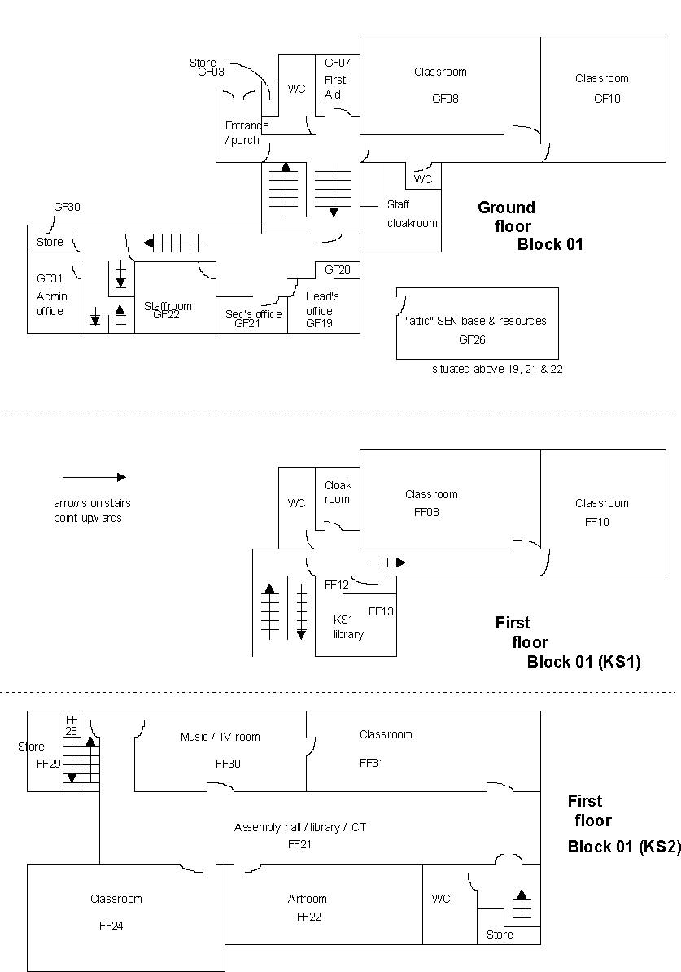

Nursery

Year
Reception

Nurture
Room
Kitchen

Heads
office

Admin
office

SENCo
Room

Year 2

MAPLE

Year 1

ELM

RWI
intervention

Nurture
Room

Library

Year 5/
6

CEDAR

Year 4/5

ROWAN

Gamelan Room

ELSA

Room

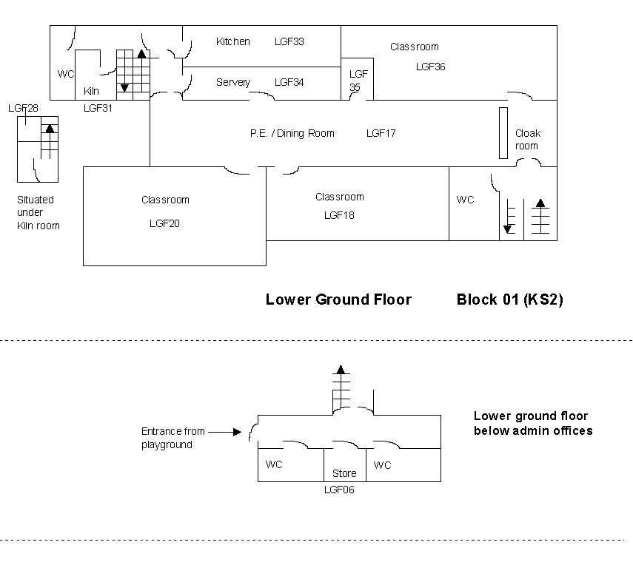

Staff room

Year 3/4

Pine

Evacuation Routes:
Year 6 – down the main stairs, out through the car park gate and around the road
Year 5 - down the back stairs and out through the Cambridge Road Rear Kitchen Doors
Years 3 and 4 - through the hall and out through the Cambridge Road Rear Kitchen Doors
Years 1 and 2 - down the entrance stairs and out through the main entrance
Foundation Stage - out the classroom door and through the outside area
Office areas - down the entrance stairs and through the main entrance

Assembly Point(s)

The designated assembly point for the school is:
on Cambridge Road, down past the rear kitchen doors. Key Stage 1 and Foundation will cross the road and meet by the gym. Key Stage 2 will meet outside of the church, on the same side as the school.

Appendix 1
THE REGULATORY REFORM (FIRE SAFETY) ORDER 2005

The following extract from the Fire Risk Assessment for Educational Premises highlights the following statutory responsibilities for schools.

If you are the responsible person you must carry out a fire risk assessment which must focus on the safety in case of fire of all ‘relevant persons’. It should pay particular attention to those at special risk, such as disabled people, those who you know have special needs, and children, and must include consideration of any dangerous substance liable to be on the premises.

There are some other fire safety duties you need to comply with:
- You must appoint one or more competent persons, depending on the size and use of your premises, to carry out any of the preventive and protective measures required by the Order (you can nominate yourself for this purpose). A competent person is someone with enough training and experience or knowledge and other qualities to be able to implement these measures properly.
- You must provide your employees with clear and relevant information on the risks to them identified by the fire risk assessment, about the measures you have taken to prevent fires, and how these measures will protect them if a fire breaks out.
- You must consult your employees (or their elected representatives) about nominating people to carry out particular roles in connection with fire safety and about proposals for improving the fire precautions.
- You must, before you employ a child, provide a parent with clear and relevant information on the risks to that child identified by the risk assessment, the measures you have put in place to prevent/protect them from fire and inform any other responsible person of any risks to that child arising from their undertaking.
- You must inform non-employees, such as students and temporary or contract workers, of the relevant risks to them, and provide them with information about who are the nominated competent persons, and about the fire safety procedures for the premises.
- You must co-operate and co-ordinate with other responsible persons who also have premises in the building, inform them of any significant risks you find, and how you will seek to reduce/control those risks which might affect the safety of their employees.
- You must provide the employer of any person from an outside organisation who is working in your premises (e.g. agency providing temporary staff) with clear and relevant information on the risks to those employees and the preventive and protective measures taken. You must also provide those employees with appropriate instructions and relevant information about the risks to them.
- If you are not the employer but have any control of premises which contain more than one workplace, you are also responsible for ensuring that the requirements of the Order are complied with in those parts over which you have control.
- You must consider the presence of any dangerous substances and the risk this presents to relevant persons from fire.
- You must establish a suitable means of contacting the emergency services and provide them with any relevant information about dangerous substances.
- You must provide appropriate information, instruction and training to your employees, during their normal working hours, about the fire precautions in your workplace, when they start working for you, and from time to time throughout the period they work for you.
- You must ensure that the premises and any equipment provided in connection with fire-fighting, fire detection and warning, or emergency routes and exits are covered by a suitable system of maintenance and are maintained by a competent person in an efficient state, in efficient working order and in good repair.
- Your employees must co-operate with you to ensure the workplace is safe from fire and its effects and must not do anything that will place themselves or other people at risk.

Appendix 2 Fire Evacuation Plan

Emergency Evacuation Plan for Ford Primary School Date: 20.09.2026 Review date: September 2027

Sound of the Alarm
The sound of the alarm is a continuous ringing bell.

Raising the Alarm
In the event of a fire, if a member of staff discovers the fire, or is informed by a visitor of a fire, the alarm will be raised by the activation of the nearest call point by breaking the glass.

If the fire is detected by the automatic detector this will trigger the fire alarm.

Action staff should take on hearing the alarm
The following actions will be taken upon the fire alarm being sounded:
- Fire Wardens will take charge and lead in the fire evacuation
- Reception Staff to dial 999 and request attendance by the Fire Service, giving their name, name of building, building address (Cambridge Road, Plymouth, PL2 1PU), contact number (01752 567661) and details of fire
- Collect register from ‘sign in’ iPad. Reception Staff are also to pick up the Emergency Red Box.
- Staff and children will commence evacuation of the building, ensuring this is done in a calm and orderly manner, assisting those who may need additional help in evacuating
- Designated Fire Wardens are to put on their fire warden high-visibility jacket, sweep the building, if safe to do so, to ensure all areas are clear and all doors are closed on the way out
- If safe to do, electrical mains and gas supplies should be switched off before leaving the building. The location of these are detailed below
- Fire Wardens are to ensure nobody re-enters the building until confirmed safe to do so by the Fire Service
- Meet at assembly point and check all visitors, contractors staff members and children are accounted for
- The PIC (Person in Control) is to liaise with Fire Service upon their arrival

Emergency Exits and Escape Routes
Any emergency exit may be used during an evacuation. There are 5 designated Emergency Exits:
- Maple & Elm Classes (yr1 & 2), Office Staff, use Main Entrance KS1 Building.
- Acorns & Oaks (Foundation unit) use the door in their unit which leads out onto the EYFS play area and out through the side gate. KS1 Building
- Willow & Pine Classes (yr3 & 4) Use Double Doors, by Main Kitchen, which leads out to Cambridge Road. KS2 Building.
- Rowan Class (yr5) use back stairs and go out the Double Doors by the Main Kitchen which leads to Cambridge Road. KS2 Building.
- Cedar Class (yr6) use Main Stairs to go out through playground & staff carpark. KS2 Building.
Fire Assembly Point
The assembly point is on Cambridge Road (just past rear kitchen doors).

Fire Extinguishers – fighting a fire
The policy is the get out and stay out as personal safety always takes priority. If in any doubt, staff should not attempt to fight a fire. Fire extinguishers should only be used if:
- Staff have received training and they feel confident in their use
- Where it is deemed safe to do so in that there is clear means of escape, the fire is very small, the nature of the fire and the correct extinguisher are known

Location of key safety hazards or other fire related equipment
- Oil/BMS system shut off is in the KS2 Boiler Room
- There is no gas to any of the buildings
- Mains electric shut off is
KS1 building – electric cupboard at the bottom of the stairs
KS2 building – electric cupboard at the bottom of the back stairs
- The fire alarm panel is by the double doors in the Main Entrance.

Variations to the Plan
Outside normal Reception hours (08:00 to 16:00) and during school holiday periods when school is closed, the alarm system is monitored by EMCS, via AWL Group.
All school run after school clubs have a trained Fire Warden in attendance, and who will act as PIC (Person in Control).

Responsibilities
For ensuring the plan is up to date and reviewed | Headteacher
For ensuring that all staff are aware and understand the plan | CEO, Headteacher
For training staff on the evacuation plan and carrying out regular drills | Headteacher
For training nominated staff on the evacuation plan, their roles and responsibilities | Headteacher

